# Comp 2002 Set Exercises – Part 1

For part 1 of the set exercises, I have decided to choose my topic as Military Applications, more specifically image recognition and image/object tracking. There are lots more applications of AI in military applications however I will be talking about specifically image recognition and image tracking.

### Introduction - What is the purpose?

The purpose of AI in this application is to track, scan and monitor not only specific targets but also detection of threats in a wide area. The reason that this is useful is due to the efficiency and accuracy in detection, it can surpass human detection and is much faster, especially when a response is required such as responding to an incoming attack.

Implementation of AI in military applications such as this means that we can do computational tasks much faster than ever before, without ever requiring human monitoring. It can also track lots more objects than a Human would be able to as they are likely to get distracted or lose track of a target while looking at another one. The reason this is so important is human error can almost be eliminated. While AI is not perfect when it comes to detection and accuracy, it has been shown time and time again that with time, lots of input data and training AI models eventually outperform human’s in almost all benchmarks consistently.

### Has it been successful so far?

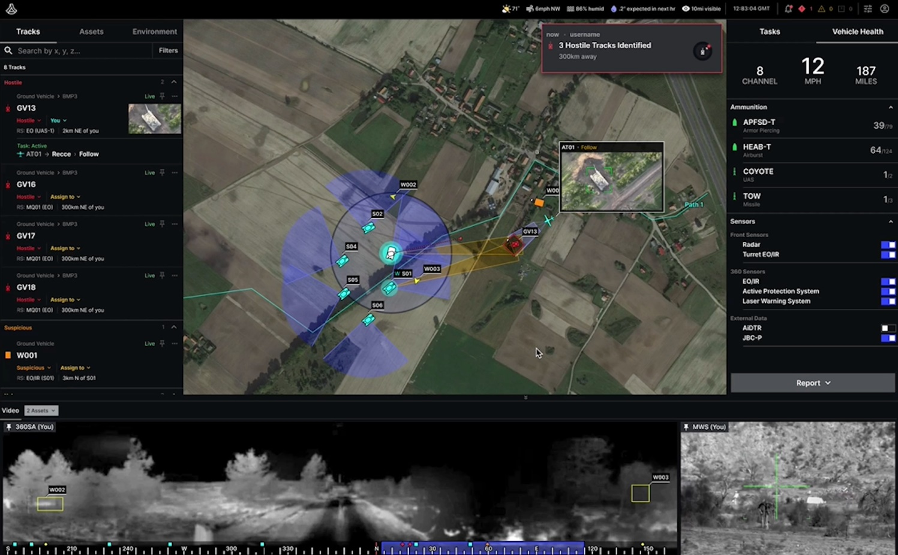Yes, there have been many implementations of AI in military applications, a specific example of this would be a company called [Anduril](https://www.anduril.com/) , they have software that is currently being used by the US DoD, here is a report by [NBC news](https://www.nbcnews.com/tech/security/inside-anduril-startup-building-ai-powered-military-technology-n1061771) about what they do.

* A screenshot of the AI tracking software used by Anduril, showing a battlefield with multiple tracked tanks, as well as enemy tanks.

One reason why it could not be successful is because AI is such a new technology, we do not know the full capabilities of it yet. Also, laws are being made to restrict what is allowed and what is not allowed. The goal of this technology is to make decisions for us and control technology that we have responsibility for. This may not be possible and brings up lots of legal and ethical issues that may cause the technology to not be as valuable as it could be.

### What has the impact of its introduction been?

This impact of AI in this application has been huge, specifically for the US DoD, they have signed many new contracts with companies like Anduril. Lots of money is being invested into technology like this and money will likely continue to be invested for a while.

Lattice, the software that Anduril uses to track areas, will be able to monitor and track hundreds of miles of terrain, all from a single operator. This is a massive improvement from current surveillance systems and allows for clients like the military to require much less human operators, allowing them to assign personnel to another task that they may be required on.

### Will it continue to be used?

There is a very high chance that this technology will continue to be used, a good way to estimate this is by looking at the contracts and investments being made into the technology. This shows the military’s confidence that this will be useful to them and will succeed. There has also been lots of investments in the company, meaning that investors – people who do thorough research into the likelihood of a technology succeeding, have large amounts of confidence that it will be continuing to be used and improved on.

### Are there any improvements required to make it better?

As with almost all implementations of AI in any field, improvements can be made and are likely to happen for a while. In this specific case it is not only being improved to expand the capabilities, but to ensure that it is reliable time and time again. Something that is an incredibly key feature when it comes to the military, as errors and false positives in this field can be catastrophic.